Venue details

The course takes place at the A. W. Robinson classroom in the woods, near Ashby-cum-Fenby in Lincolnshire.

The classroom is situated at the end of a long farm track off the A18, west of Grimsby. Please bring outdoor shoes/wellington boots and outdoor clothing.

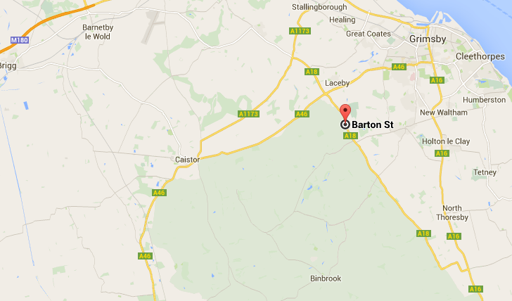

Directions
From the North
Leave M180 at Junction 5. Follow the A18 towards Louth.
Continue along the A18 to the Laceby roundabout.
Continue along the A18 towards Louth for a further 3 miles.
The A. W Classroom in the woods is situated on your left, before the Waltham roundabout.

From the South
Follow the A16 through Louth, heading towards Grimsby.
Turn left onto the A18, travelling towards Brigg.
Continue along the A18 to the Waltham roundabout.
Continue straight ahead along the A18 for approximately ½ mile.
The A. W Classroom in the woods is situated on your right.

